Transportation
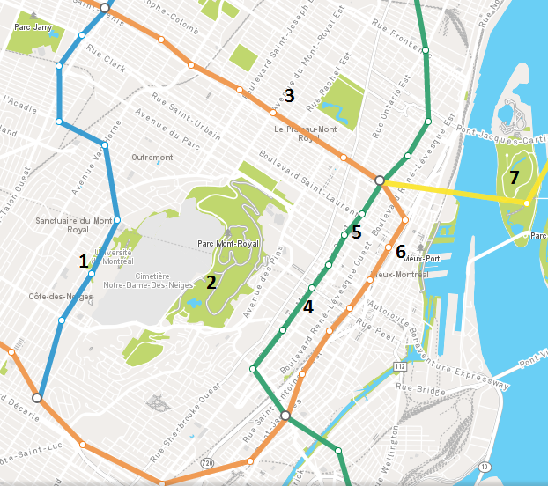
Num | Name | Activities | Closest Metro Station
1 | HEC Montreal | Conferences | Université de Montréal (blue line)
2 | Mount Royal park | Trek, picnic, panoramic view of the city (Le belvédère) | Access from Côte des neiges street (bus 165)
3 | Plateau mont-royal | Old architecture, restaurants, bars etc. | Mont-Royal  (orange line)
4 | Downtown | Shopping malls, museums | Peel (green line)
5 | Quartier des spectacles | Entertainment district : concerts, festivals and events | Place-des-arts  (green line)
6 | Old port | Walk in the old city, walk by the dock, art galleries, restaurants, bars | Place d’armes  (orange line)
7 | Jean Drapeau parc | Environment Museum, Aquatic complex, beach, shows | Jean-Drapeau  (yellow line)

Metro Plan
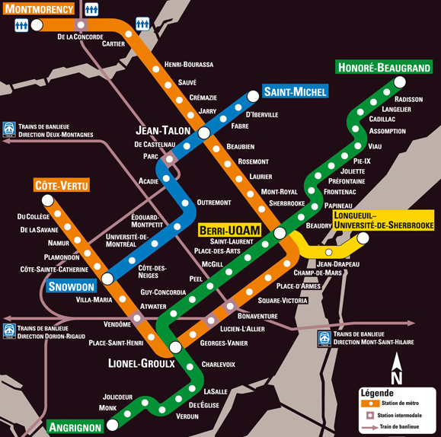

Useful Buses
- 165 côte des neiges station (blue) <–> Guy Concordia station (Geen)
- 129 HEC Montreal <–> Place-des-arts station (Green)
- 51 HEC Montreal <–> Laurier Station (Orange)
- 80 Parc station (blue) <–> Place-des-arts station (Green)

July 22 activities
- Biodôme, Montreal Tower and Botanical Garden: located next to Viau station (green line), the metro is the easiest and fastest way to get there.
- Boat Tour, boarding and ticket office are on Jacques Cartier Dock.
From Place-d’Armes station (orange), turn right on Saint-Urbain street. Turn left on Saint Antoine street. Turn right on St-Laurent blvd. Turn right on de la Commune street and go straight for around 300m.

Bonne visite !

Culinary discovery
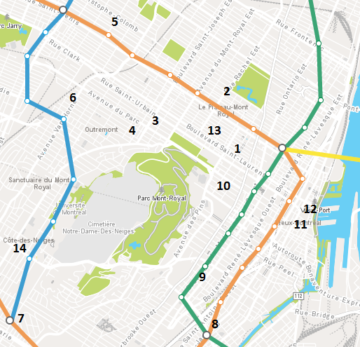

Schwartz's Deli
Famous Montreal Smoked Meat, open since 1928
3895 Saint-Laurent Boulevard

La banquise
Best Poutine in town
994 Rachel street East

La buvette chez simone
Wine tasting and bistro cuisine
4869 Parc Avenue

Leméac
French restaurant
1045 Laurier avenue West

Pho Tai Ho
Excellent Phò and Vietnamese cuisine
6414 Saint Denis Street

Damas Restaurant
Syrian, Middle East and Mediterranean cuisine
1201 Van Horne Avenue

Masala Palace
Indian cuisine
4961D Queen Mary

Joe Beef
Seafood and steakhouse
2491 Notre Dame West

Kazu
Excellent authentic Japanese cuisine with a touch of modernity. A must!
1862 Sainte-Catherine West

Lola Rosa
Modern vegetarian
545 Milton Street

L’original
Canadian sea food
479 Saint-Alexis Street

Méchant Boeuf
Steakhouse
124 Saint Paul West

Khyber Pass
Afghan cuisine
506 Duluth Avenue

Restaurant Tuk Tuk
Cambodian and Thai
5691 Côte des neiges

Other restaurant alternatives by area.

Around HEC/Côte-des-Neiges

Restaurant Oriental Nganh Dinh
Small informal, Excellent Phò, vietnamese specialties, best pan fried dumplings
5540A Ch de la Côte-des-Neiges, Tel : 514-731-0663

Restaurant Britt & Chips
Fish and Chips
5536A Ch de la Côte-des-Neiges, Tel : 514-737-9555

Restaurant Tuk Tuk
Cambodian (open 17 :00 – 22 :00)
5619A Ch de la Côte-des-Neiges, Tel : 514-739-6132

Restaurant Kam Shing
Chinese (informal)
6730 Ch de la Côte-des-Neiges, Tel : 514-731-1401

Les tontons flingueurs
French Bistro
5190 Ch de la Côte-des-Neiges, Tel : 514-733-0606

Olivieri Librairie Bistro
French, light meals
5219 Ch de la Côte-des-Neiges, Tel : 514-739-3303

Pizza Fiore
Pizza and pasta
3518 Avenue Lacombe, Tel : 514-739- 735-1555

Laurier/Bernard ave. area

Maïko Sushi
Very good sushi , japanese cuisine, reservations recommended
387 Rue Bernard O, Tel : 514-490-1225

Les enfants terribles
French bistro
1257 Rue Bernard, Tel : 514-759-9918

Chez Lévëque
French bistro
1030 Av Laurier O, Tel : 514-279-7355

Le comptoir Charcuteries & Vins
French cuisine
4807 Boul Saint-Laurent, Tel : 514-844-8467

Nonya
Indonesian
151 Rue Bernard O, Tel : 514-875-9998

Bilboquet
French style ice cream
1311 Av Bernard

